Text Connections
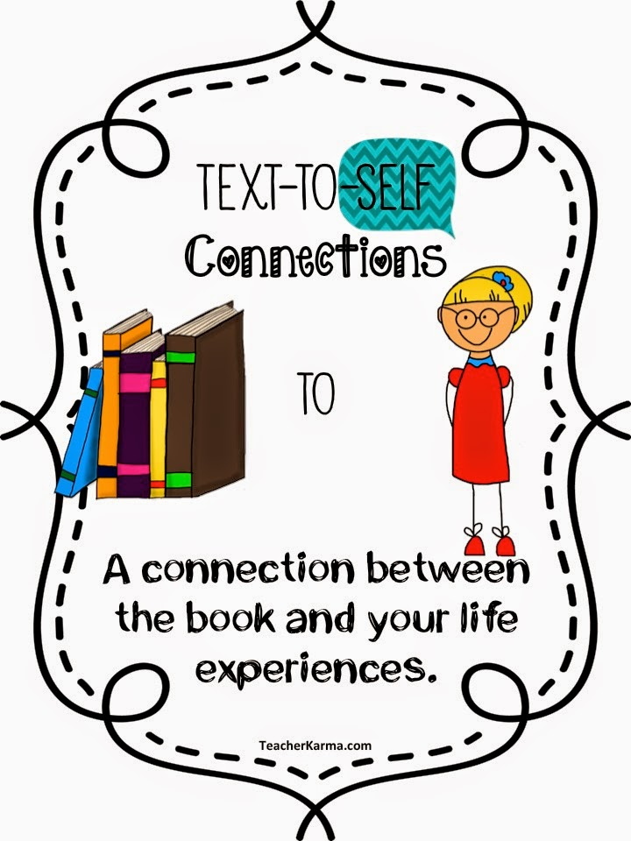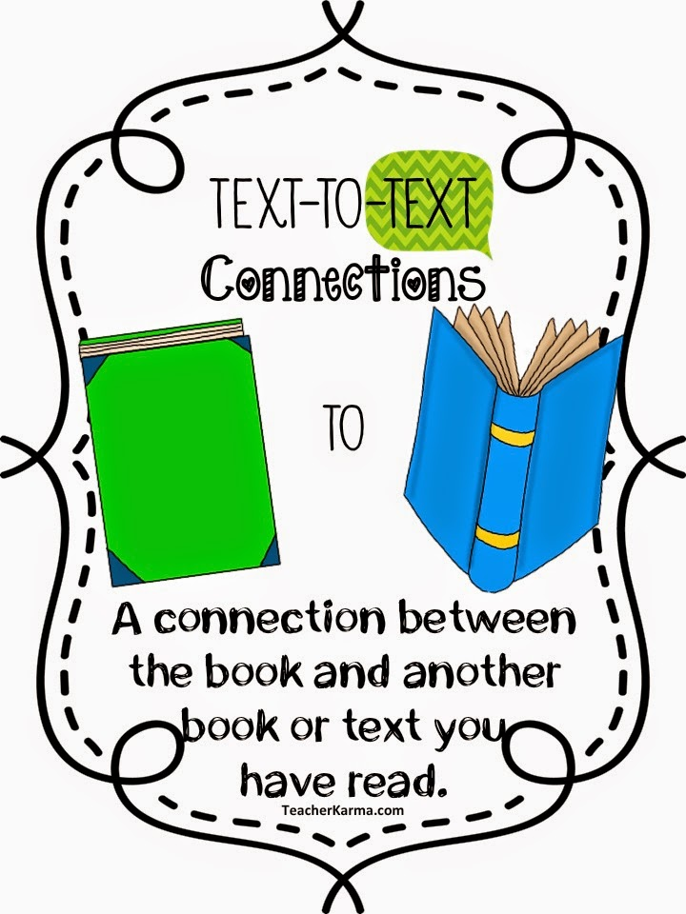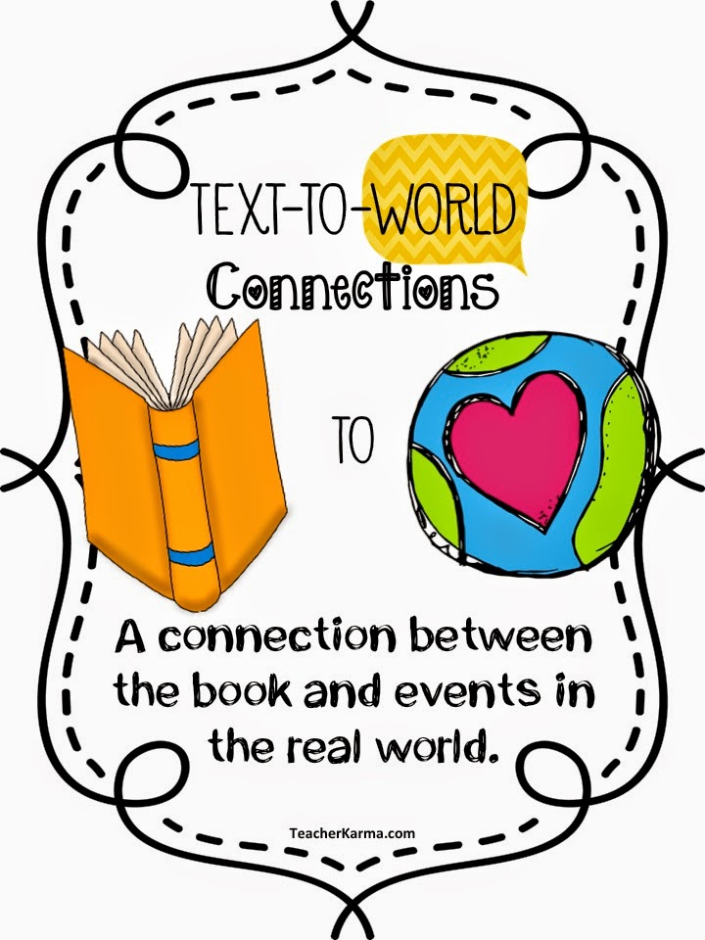

Questions to think about when making connections:
Focusing on text-to-self | Focusing on text-to-text | Focusing on text-to-world
- What does this story remind you of?  - Can you relate to the characters in the story?  - Does anything in the story remind you of anything in your own life? | - What does this remind you of in another book you have read?  - How is this text similar to other things you have read?  - How is the text different from other things you have read? | - What does this remind you of in the real world?  - How are events in this story similar to things that happen in the real world?  - How are events in this story different from things that happen in the real world?

